

FUNCTIONAL SPECIFICATION DOCUMENT

Application: Budget Expenditure & Asset Management Management System

|  |  |
| --- | --- |
| Project | Seatrium Leagacy Application Discovery |
| Version | 1.0 |
| Effective Date | 22-Apr-2025 |

Table of Contents

**RECORD OF CHANGE** 3

**I. SUPORTED APPLICATIONS** 4

**1. BUDGET EXPENDITURE & ASSET MANAGEMENT SYSTEM (BEAMS)** 4

**Overview** 4

**Screenshots** 4

**Functional Specification** 7

**Stakeholders** 8

**Key Issues/Challenges** 8

**End of Document** 8

# **RECORD OF CHANGE**

| No | Modified Date | Version | Change Description | Author | Reviewer | Approver |
| --- | --- | --- | --- | --- | --- | --- |
| 1 | 22-Apr-2025 | 1.0 | (Initial Version) | Thuy Le Thi Thanh (Gina) | Phuong Tran Huynh Huy (Matthew);  Minh Tran Duc | Sihhu/ Deepan/ Faang |

# **I. SUPORTED APPLICATIONS**

## **1. BUDGET EXPENDITURE & ASSET MANAGEMENT SYSTEM (BEAMS)**

### **Overview**

The **Budget Expenditure & Asset Management System (BEAMS)** is a web-based enterprise solution used for managing the full cycle of departmental budgeting and requisitions. It streamlines CAPEX and Special Overhead budget planning, submission, revision, approval, and expenditure tracking. The system is mainly used by the Finance Department.

### **Screenshots**

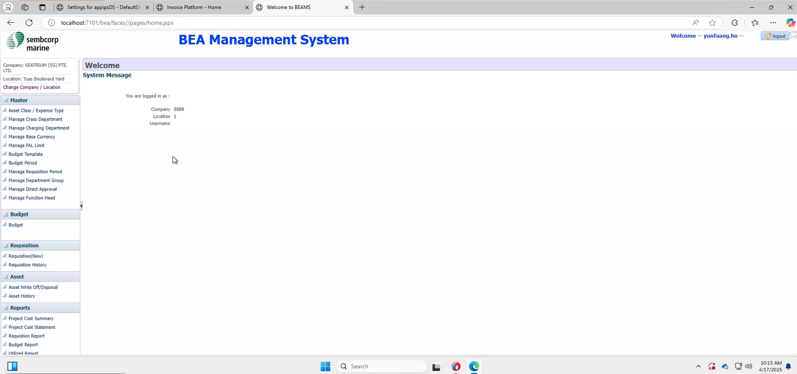 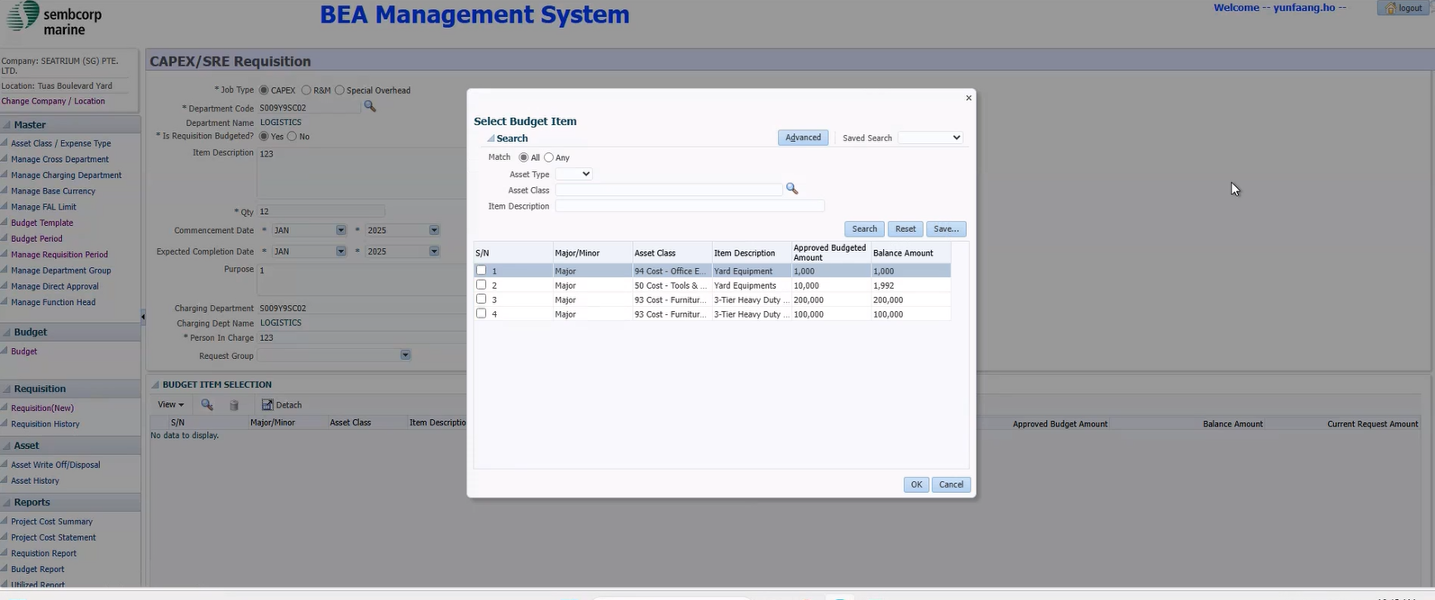

### **Functional Specification**

|  |  |  |
| --- | --- | --- |
| **S/N** | **Module** | **Description** |
| 1 | Budget Preparation | Finance prepares and submits Excel-based departmental budgets to IT for uploading. |
| 2 | Budget Viewing | Users can view their department's budgets with fields like approved, utilized, and balance. |
| 3 | Revised Budget Submission | Enables transferring budget lines between departments with an approval workflow. |
| 4 | Requisition Management | Users create CAPEX/SRE requisitions linked to approved budget lines. |
| 5 | Approval Alerts | Notifications sent to finance for budget revisions. |
| 6 | Reports | Summary, cost statement, and history reports available per user role. |
| 7 | Forecast Tab | Reserved for future budget forecasting (currently not in use). |

**Addtional Information 1**: High-level Flow

|  |  |  |
| --- | --- | --- |
| **Step** | **Functionality Area** | **Description** |
| 1 | Login & Access Control | Login requires Company Code & Location. Access based on user roles. |
| 2 | Budget Viewing | View approved budget amounts, utilization, and balances per department. |
| 3 | Budget Preparation | Finance prepares budgets in Excel, IT uploads into BEAMS manually. |
| 4 | Revised Budget | Add/edit budget transfer lines with justification. Locked until approved. |
| 5 | Requisition Creation | Users select budget item, input details, and submit requisition. |
| 6 | Approval Platform | Revised budgets and requisitions go through approval routing. |
| 7 | Requisition History | View past requisitions including BEAMS No., status, and amounts. |
| 8 | Forecasting (future) | Reserved tab for upcoming forecast feature. |

**Additional Information 2**: Business Rules

1. The Master module is maintained by Finance.
2. Users must select a valid combination of Company Code and Location Code to log in.
3. Each budget entry must belong to a defined Job Type: CAPEX, R&M (used in SAP), or Special Overhead.
4. Once a revised budget is submitted, it cannot be edited until approved.
5. Cross-department requisitions require pre- configuration by Finance in the Manage Cross Department module.
6. Department users see only their data; Finance, CEO, CFO have global view access.
7. Finance provides Excel to IT, who manually uploads budget period and budget data into database.
8. Budget revisions sent to Approval Platform for routing and approval confirmation.

### **Stakeholders**

|  |  |  |
| --- | --- | --- |
| **S/N** | **Role** | **Access Level** |
| 1 | Finance | Full access to all modules and departments. Can upload budgets. |
| 2 | Department User | View-only budget access. Can create requisitions for own dept. |
| 3 | IT Support | Handles uploads and system issues on request. |
| 4 | High-level roles (CEO/ CFO) | Can view all budgets, cross-department requisitions, and analytics reports. |

### **Key Issues/Challenges**

**1. Manual Data Handling:** Currently, budget data is handled manually, with finance preparing Excel files for IT to upload into the system, reflecting a lack of automation.

**2. Department-Specific Access:** Users are restricted to viewing or managing budgets for their own department, except for high-level roles (e.g., Finance, CEO, CFO) who can access all department budgets.

➝ This role and permission control is currently in place pending Finance's finalization of the workflow, after which BEAMS will undergo necessary enhancements.

**3. Limited Forecasting Functionality:** The forecasting tab is not currently in use, reducing its potential utility for future budget planning.

### **End of Document**